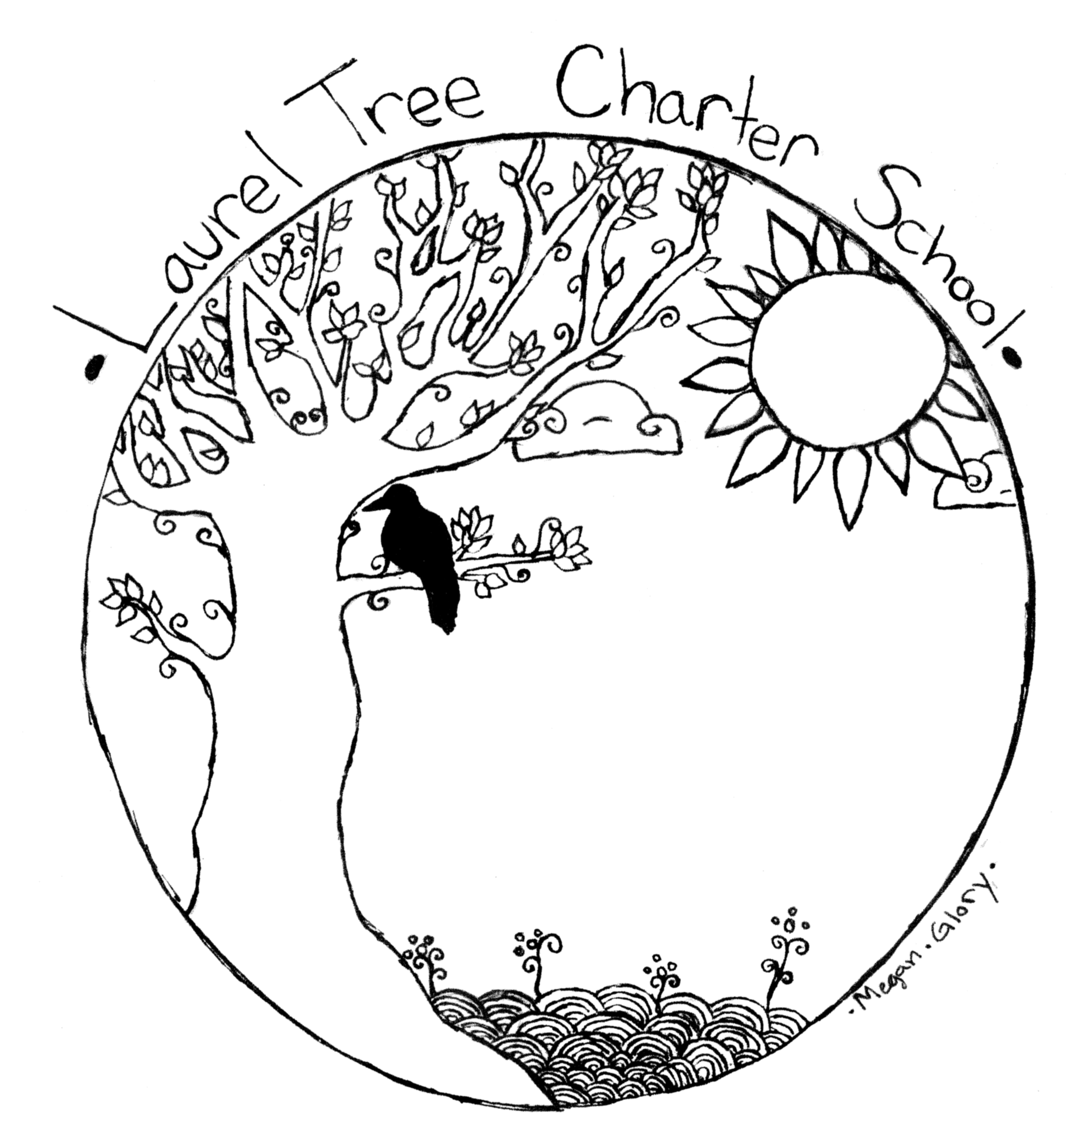 | Laurel Tree Charter School  Creating the Education We Want For Our Children  Rigor*Relevance*Relationships*Responsibility*Regeneration  4555 Valley West Blvd, Arcata, California 95521  (707) 822-5626 * www.laureltreecs.org  Laureltree_lc@yahoo.com

Laurel Tree A-Z
Aftercare/Before School Care
We provide drop-in supervised play and activities in aftercare for kindergarten starting at 1:00, and for our 1st-6th grade students from 3:30 to 5:30, at $3.50 an hour (invoiced the following month). Daycare policies and contract are included in the back-to-school mailing. We provide care in the morning (and a breakfast snack) from 7:00 am to 8:00.

Art
This year our artist-in-residence, Michelle Remy, teaches High School Art and integrates art into our English, Math and Science courses. This year her high school class is called Art Masters. You can see art from our students all over the school.

Attendance
If your student arrives after 8:30, we mark them late. If your student is thirty minutes late to school, we mark them tardy. If they are not there at all that day, we mark them absent. You will get an e-mail alert via our on-line system any time they are tardy or absent. Three tardies = one unexcused absence (these can’t be made up).
Three unexcused absences or tardies of more than 30 minutes = truancy notice
Two truancy notices = Parent/School Psychologist meeting to discuss support for helping the child attend regularly and on time. An attendance improvement plan will be signed by student, parents, and teacher(s).
Three truancy notices = Mandatory appearance before the School’s Governing Board. The student is now “Habitually Truant”. The board will provide a warning that child protective services and/or the County Student Attendance Review Board may be involved. The board will offer community support or resources. (For more information see our complete Attendance Policy)
We want to make it easy for you to make up days when your student is absent, or when you go on a family trip. See Caroline about getting an independent study packet. Please fill out this independent study packet before you go on a family trip, or to make up work from an extended absence (more than three days). Turning in one of these sheets, with the work attached, allows us to collect the ADA money – and helps your child stay caught up in school. Please return to Caroline.

Birthdays/Holidays
We love to celebrate! Holidays of many traditions are shared. You are welcome to bring a treat to share for your child’s birthday. We encourage healthy foods, but special treats are fine. Some children have allergies – check with the front office so you can have an alternative for kids that need them.

Busing
We don’t have school buses or provide transportation to and from school. We rely on parent drivers, carpooling and mass transit. We have two school vans that are used for our Forest Kindergarten Program in the morning and our Laurel Tree Wild Program in the afternoon. We rely on parents volunteers to provide us with drivers and chaperones for our many field trips.

Cell Phone Policy
We believe it is our duty to teach responsible use of electronic devices to students with the appropriate maturity level. All students in primary and middle school must have devices turned off during the school day. All high school students are given opportunity to engage in responsible use of devices during appropriate school day times. Consequences for irresponsible use are defined below:
Responsible Use:
- During class, devices may only be used for related coursework (i.e. calculations, research, listening to music at appropriate times, etc.) with prior teacher/student communication.
- During breaks and before/after school, devices may be used for personal use, with the exception of gaming.
Irresponsible Use will result in the following, as deemed necessary by staff members:
- Teacher(s) will confiscate device and hold it until end of class period.
- Teacher(s) will confiscate device and take it to office for parent pick-up. Teacher will contact parent.
- If a pattern of irresponsible use arises then a teacher/parent/student conference and contract will be required.
Communication -Parent/Teacher Meetings
It takes a village to raise a child, and we want great communication in our village. Every Monday we send out our Monday Note via e-mail. It has information about what’s happening around the school that week. Parents have access to their students’ grades, assignments, and to teachers’ e-mail addresses via our on-line grading system. Our website (www.laureltreecs.org) has lots of information, including our calendar. E-mail or a message through Jupiter Ed is a good way to reach us with a quick question or concern.
If you are not on-line, you can pick up a copy of the Monday Note at school. The school computer lab is available after school if you need access to a computer to check grades. Teachers are always glad to chat with parents – so long as it’s not during class.
We have scheduled parent/teacher conferences once a year for the primary students (with early dismissal at 1pm during conference week). We schedule them as needed for the older students. We also love having parents in the classroom. We ask only that you set up observation/helping time with the teacher ahead of time and that you not interrupt class time to talk to a teacher. We're very accessible before classes, after school, and via the internet - schedule a meeting so we can give you our full attention. We feel that a strong connection between teachers and parents is essential for the success of our students.

Counseling
Our full-time school psychologist, Chester O’Neal works with our team to help support students. He provides counseling to students, uses restorative practices to help students resolve problems, and provides testing that helps us understand how kids learn. He does observations of students and provides helpful feedback for teachers. He helps us write behavior plans, and he can provide resources and counseling connections for families.

Discipline
A calm, safe, and predictable classroom is essential to learning. When students help decide the rules and know that those rules will be fairly enforced, then behavior problems decrease and the amount of time for teaching and learning increases. With this in mind, we have students participate in setting up our classroom rules. However, students need firm, fair boundaries and grown-ups that they can count on to be in charge. Therefore, all adults in our classrooms use the following system. It is a positive way to create a respectful learning environment, as well as to help students reflect on and change behavior that is hindering their learning.
1. Proximity – Move near the student who needs support or is off task (often the same thing).
2. Praise - Praise the desired behavior in other students. “You guys are doing a great job working on that math sheet.” Praise approximate behavior changes in the student. “Good job getting started. Do you need any help?” Usually your positive presence and your offer of help are all it takes to help students get back on track.
3. Redirection – Tell the student what you want them to do, not what you want them to stop doing. “Please pick up your pencil and I’ll help you get started on this.”
4. Reflection/Replay - As a final step, students who continue to disrupt the learning environment will be sent out of the classroom. There, in a quiet, supervised space they can calm down, fill out a behavior sheet, resolve whatever the issue is, and then return to class. Students will meet with their teacher during the next break to go over their behavior sheet and decide on the consequences of their actions (mediation, restitution, making up missed work, in school suspension, or parent contact). Any out-of-control behavior (tantrums, violence, and defiance) will be excused immediately to Reflection/Replay.
We have board adopted policies that deal with more severe behavioral issues such as bullying or violence. Our suspension and expulsion policies are clearly spelled out and in accordance with California Education Code. See our full discipline policy at the back of this booklet.

Dress Code
We expect our children to come in clothes (and shoes) that allow them to run and play and move freely. We are often outdoors for learning and we expect students to dress appropriately for the weather. We respect diversity of expression among our older students so long as clothing does not contain drug references, racial slurs, or profanity.

Enrollment
We are usually full. When we have space available, we take people off our wait list on a first come, first serve basis, with a priority given only to siblings of students already enrolled. To get on the wait list, we ask that parents and their student come and observe at the school, meet with the teachers, and fill out a pre-enrollment form. We hold a lottery twice a year with the pre-enrollment forms. We add the names to our wait list in the order they were drawn from the lottery. Your student’s name remains on the wait list until we have space for you. We call everyone on the wait list in May to let them know whether they have a space for the following year.

Fieldtrips
We take a lot of fieldtrips. Forest Kindergarten is a field trip three day a week. Our afternoon program for 1st-8th grade, Laurel Tree Wild, is off site for Community Classes and Tidal Zone Explorers.
The older kids (5th and up) camp together for a week at Camp Ravencliff. They usually travel to the Oregon Shakespeare Festival to see several plays in the fall, and plan a longer trip in the spring based on something they are studying. Parents are welcome and encouraged to attend as chaperones.

GATE
We think all of our kids are gifted and talented, and we want an enriched, exciting curriculum for them all. Therefore, we provide challenging lessons, hands-on activities, and higher-order thinking assignments every day; we offer enrichment classes for everyone through our Laurel Tree Wild Program; we include all our students in theater productions and travel opportunities; and we support all our students to work at their highest ability level, not just their grade level.

Grades and Assessments
We use different types of assessment to help us know how our students are doing, where they need more help, and where they need more challenge. We use rubrics, portfolios, teacher observations, performance assessments, and standardized tests. These are all valuable tools that help teachers and students assess their learning and plan the next steps. We plan instruction using the Common Core Standards. We give letter grades based on these different assessments for 5th grade and up. For our primary students we use “meet, proficient, emerging and concern” to indicate their progress. Report cards are given twice a year. Rubrics assessing specific skills are given at the end of each Laurel Tree Wild session. Parents can see grades and assignments, and contact teachers through our online grading system at www.jupitered.com. See office for login information.
While we do not believe that grades accurately reflect the vast breadth and scope of students’ intelligence, we do believe they reflect how good students are at “school skills” like organization, follow through, asking for help, and working hard. These are important, and being good at these things can be a good indicator of future success.

Groupings – Multi-graded
We believe in multi-age, multi-graded, and ability grouping whenever possible. People of different ages working together promotes cooperation and community, and decreases competiveness and anxiety. Students have the opportunity to work above or below “grade level” so they can be supported or challenged as they need.
We use color names to denote the different groupings. Red, Orange, Yellow and Green are the four groups in primary. Students move through the different groups at different rates. When they complete the academic and social goals necessary for moving on to the middle school group, then they do so (usually by the end of 4th or 5th grade).
Blue, Indigo, Violet and Gold are the groupings in 5th-12th. Right now, these classes are determined by math ability groupings. The staff has the flexibility to create classes that best meet the needs of the group we have that year.
Students spend different amounts of time in different color groups. One student may need three years in Blue before they’re ready for Integrated 1 in Indigo. Some students are ready to go into Indigo their second year. All students are expected to complete the social and academic requirements for middle school before moving into high school and the Gold Group.
In their 11th and 12th grade year, students are encouraged to take classes through concurrent enrollment at College of the Redwoods, so they can be ready for the transition to college. High School Graduates must meet all state requirements for graduation.

Library
All library books (primary through high school) must be checked out via the school librarian prior to removal from school grounds. The check-out period is 30 days with one renewal allowed. Return books to the baskets provided in the library. If a book is not returned, parent(s)/guardian(s) will be billed for either a replacement book or replacement costs and the student's check-out privileges will be suspended until the book is returned or replaced.

Lunch Program
Our kitchen manager cooks a simple, nutritious, vegetarian meal four days a week (Mon-Thrs) for our lunch program. The whole school sits down to eat together in cross-age tribes. Students can bring lunch from home or eat school lunch. The lunches are $3.50 a day (invoiced the following month). No school lunch provided the first week of school or in June.

Nurse
Our nurse comes from the County Office of Education to do hearing and vision screening, and to consult on an as needed basis.

Parent Involvement
We strongly encourage, and indeed depend upon, family involvement with our school. We believe family involvement is critical to the success of children AND to the success of our school. You are your child’s first teacher. You are an important part of our sustainable school community.
We come together as a community four times a year at our Potluck and Performance gatherings. This is where we see the culmination of our Laurel Tree Wild sessions. One group puts on a play, there are demonstrations or displays from Community Classes, Tidal Zone Explorers, Edible Education, and Forest Kindergarten.
We also have several fundraisers that we need parent help with: Boffing Swords in September/October, Cookie Sales in October/November, and any other opportunities raise money for student travel. Parents are also welcome to come to our monthly Board Meetings.

PE/Motor Skills
Our Laurel Tree Wild program provides a block of time in the afternoons for students in 1st-8th grade to work on motor skills, cooperation, and physical skills. Whether it’s movement games in theater class, hiking in Tidal Zone Explorers, swimming lessons and rock climbing in Community Classes, or gardening during Edible Education, we provide plenty of physical activity for growing bodies.

Individualized Education
We provide specialized academic support based on individualized education plans. Our resource team works with students in the classroom setting as well as providing small group instruction outside the classroom. Students have access to occupational therapy and other IEP driven services as needed. Our speech therapist is on campus two days a week and provides individual and small group speech therapy, as well as providing support and advice for our teachers.

School Schedule
Kindergarten: 8:30 -1:00 Monday through Thursday. 8:30 am to 12:00 pm on Friday.
Primary: School starts at 8:30 am. and ends at 3:30 Monday through Thursday, except during conference week when school is dismissed at 1pm. Fridays are from 8:30 to 12:35.
Older Students: School starts at 8:30 and ends at 3:30 Monday through Thursday. Fridays are from 8:30 to 12:35.

Sports
We have a track team that meets afterschool. Many of our students play in city recreation leagues, or for their districts of residence.

Unanswered Questions?
Check our website at www.laureltreecs.org, give us a call at 822-5626, or e-mail Brenda at laureltree_lc@yahoo.com.

Laurel Tree Charter School Discipline Policy

At LTCS, we expect and require our students to attend regularly, to demonstrate good work and study habits, and to show mutual respect to each other and teachers. We will not tolerate substance abuse, violence, or behavior that creates an unsafe emotional or physical environment.
In order to enforce these expectations, we use a progression of natural and logical consequences that are designed to help kids learn from the choices they make. Our focus is on solving problems and helping kids make better choices instead of punishment.
1. All teachers use the school-wide policy of Proximity, Praise, Redirect, and Reflect in their classrooms. Teachers move near a student who is off task, needs help or is disrupting learning, they praise the desired behavior that they see other students exhibiting, they redirect the behavior - and if the disruption continues they ask the student to step out of the classroom to reflect on the issue using a behavior sheet.
2. Behavior sheets give the student a chance to reflect on and replay the situation. They may also require that students deal with the problem by making up missed work, mediating the problem if it involves another student, fixing or pay for anything damaged, and taking the behavior sheet home to have it signed.
3. Any serious behavior issues at school are followed up by a parent contact. We contact parents via email, phone calls, face-to-face contact, and/or sending behavior reflection sheets home.
4. Mediation or consequences? We use peer mediation to help students resolve conflicts when both parties are willing to do so, and when it’s appropriate. Often the mediation resolves the issue between the students, but then the consequence for the behavior is dealt with separately. For example, if a second grader hits another second grader, we would use mediation to help the two kids work out the problem. There would also be a consequence for hitting someone. The two are separate issues. We try to use natural and logical consequences whenever possible:
Possible consequences for misbehavior: 1) Loss of recess 2) Restitution: fix the problem, pay for the object, etc 3) Community service: give something back to community that was disrupted 4) Confiscation: the distracting object is taken away for the day, week, or for good 5) Reflective writing: essay, behavior sheets, letters home 6) Loss of privileges: field trips, off-campus privileges 7) Phone call home 8) Sent home for the day.
5. In cases where the student’s behavior brings harm to or affects the community in a negative way, we may use Circle Justice as a way to hold the student accountable to the community and have the community help resolve the problem. This is a form of restorative justice.
6. For repeated issues or patterns of behavior (including lack of attendance), we may require parent-teacher conferences. If the behavior does not change after conferences and interventions, we may recommend that they leave the school. If a student’s behavior is threatening to the safety of him/herself or others in the school, we may suspend students for up to ten days. Suspension may be in-school or off-campus. For serious or repeated offenses, the Administrative Team can recommend expulsion to the Board.
7. More serious stuff. There are certain things defined in Ed Code that are more serious. Physical violence, a pattern of bullying, weapons, drugs, sexual harassment, etc. In these cases we follow Ed. Code and state law. Law enforcement may be called. Students are suspended for up to ten day, pending expulsion proceedings by the School Board.

Laurel Tree Charter School Attendance Policy

We have two major concerns regarding attendance:

- Academic success is directly tied to attendance.
- School funding is directly tied to attendance

However, we feel strongly that sick kids should stay home, and that families should have the opportunity to travel together. We also want to keep the bureaucracy and paperwork to a minimum, and we're not interested in passing judgment on whether or not the absence was for valid reasons. As their parent, you are in a better position to judge that than we are. So we (and the state) are defining excused absences as those where the student is absent due to illness, quarantine, medical appointment, family reason, travel, and religious observance. Please call and let us know why your student is out. We will put together a packet of missed work and put it in your parent cubby. By doing the missing work your student stays caught up, and we are able to receive funding from the state. Unexcused absences are when you have not called to let us know why your child is out sick, or if they are simply out for no valid reason.

Attendance Policy:

- Three unexcused absences or tardies of more than 30 minutes = truancy notice
- Two truancy notices = The School Psychologist and the Lead Teacher will set up a Restorative Circle to discuss support for helping the child attend regularly and on time. Our goal is to help the family identify the barriers to attendance and then provide support in removing those barriers. An attendance improvement plan will be signed by student, parents, and teacher(s).

Cutting School

“Cutting school” is leaving school without permission from school personnel AND parents. Consequences can include: phone calls home, a daily participation grade of “F”, restriction of off-campus privileges, loss of tribal responsibilities, and loss of participation in off-campus field trips.

Unexcused absences (as discussed in the Attendance Policy above) will include absences due to cutting school.

Commitments

Laurel Tree’s Commitment to Families

As the staff of Laurel Tree, we will:
Provide students with a positive learning environment
Foster communication between school and home
Nurture responsible, caring, and creative citizens
Encourage an atmosphere of mutual respect between staff, students, and community

Parent’s Commitment to the Laurel Tree Community

As a Laurel Tree parent, I will:
Make sure my child gets to school on time
Help my child with homework and projects
Communicate with teachers about any concerns I may have, at appropriate times
Pay lunch and daycare bills on time

Student’s Commitment to the Laurel Tree Community

As a Laurel Tree student, I will:
Come to school on time and prepared
Participate in activities with a positive attitude
Be willing to take risks in learning new concepts and meeting new friends
Take responsibility for my learning at school and at home
Respect myself, my classmates, my teachers, and all community members
Do weekly homework

