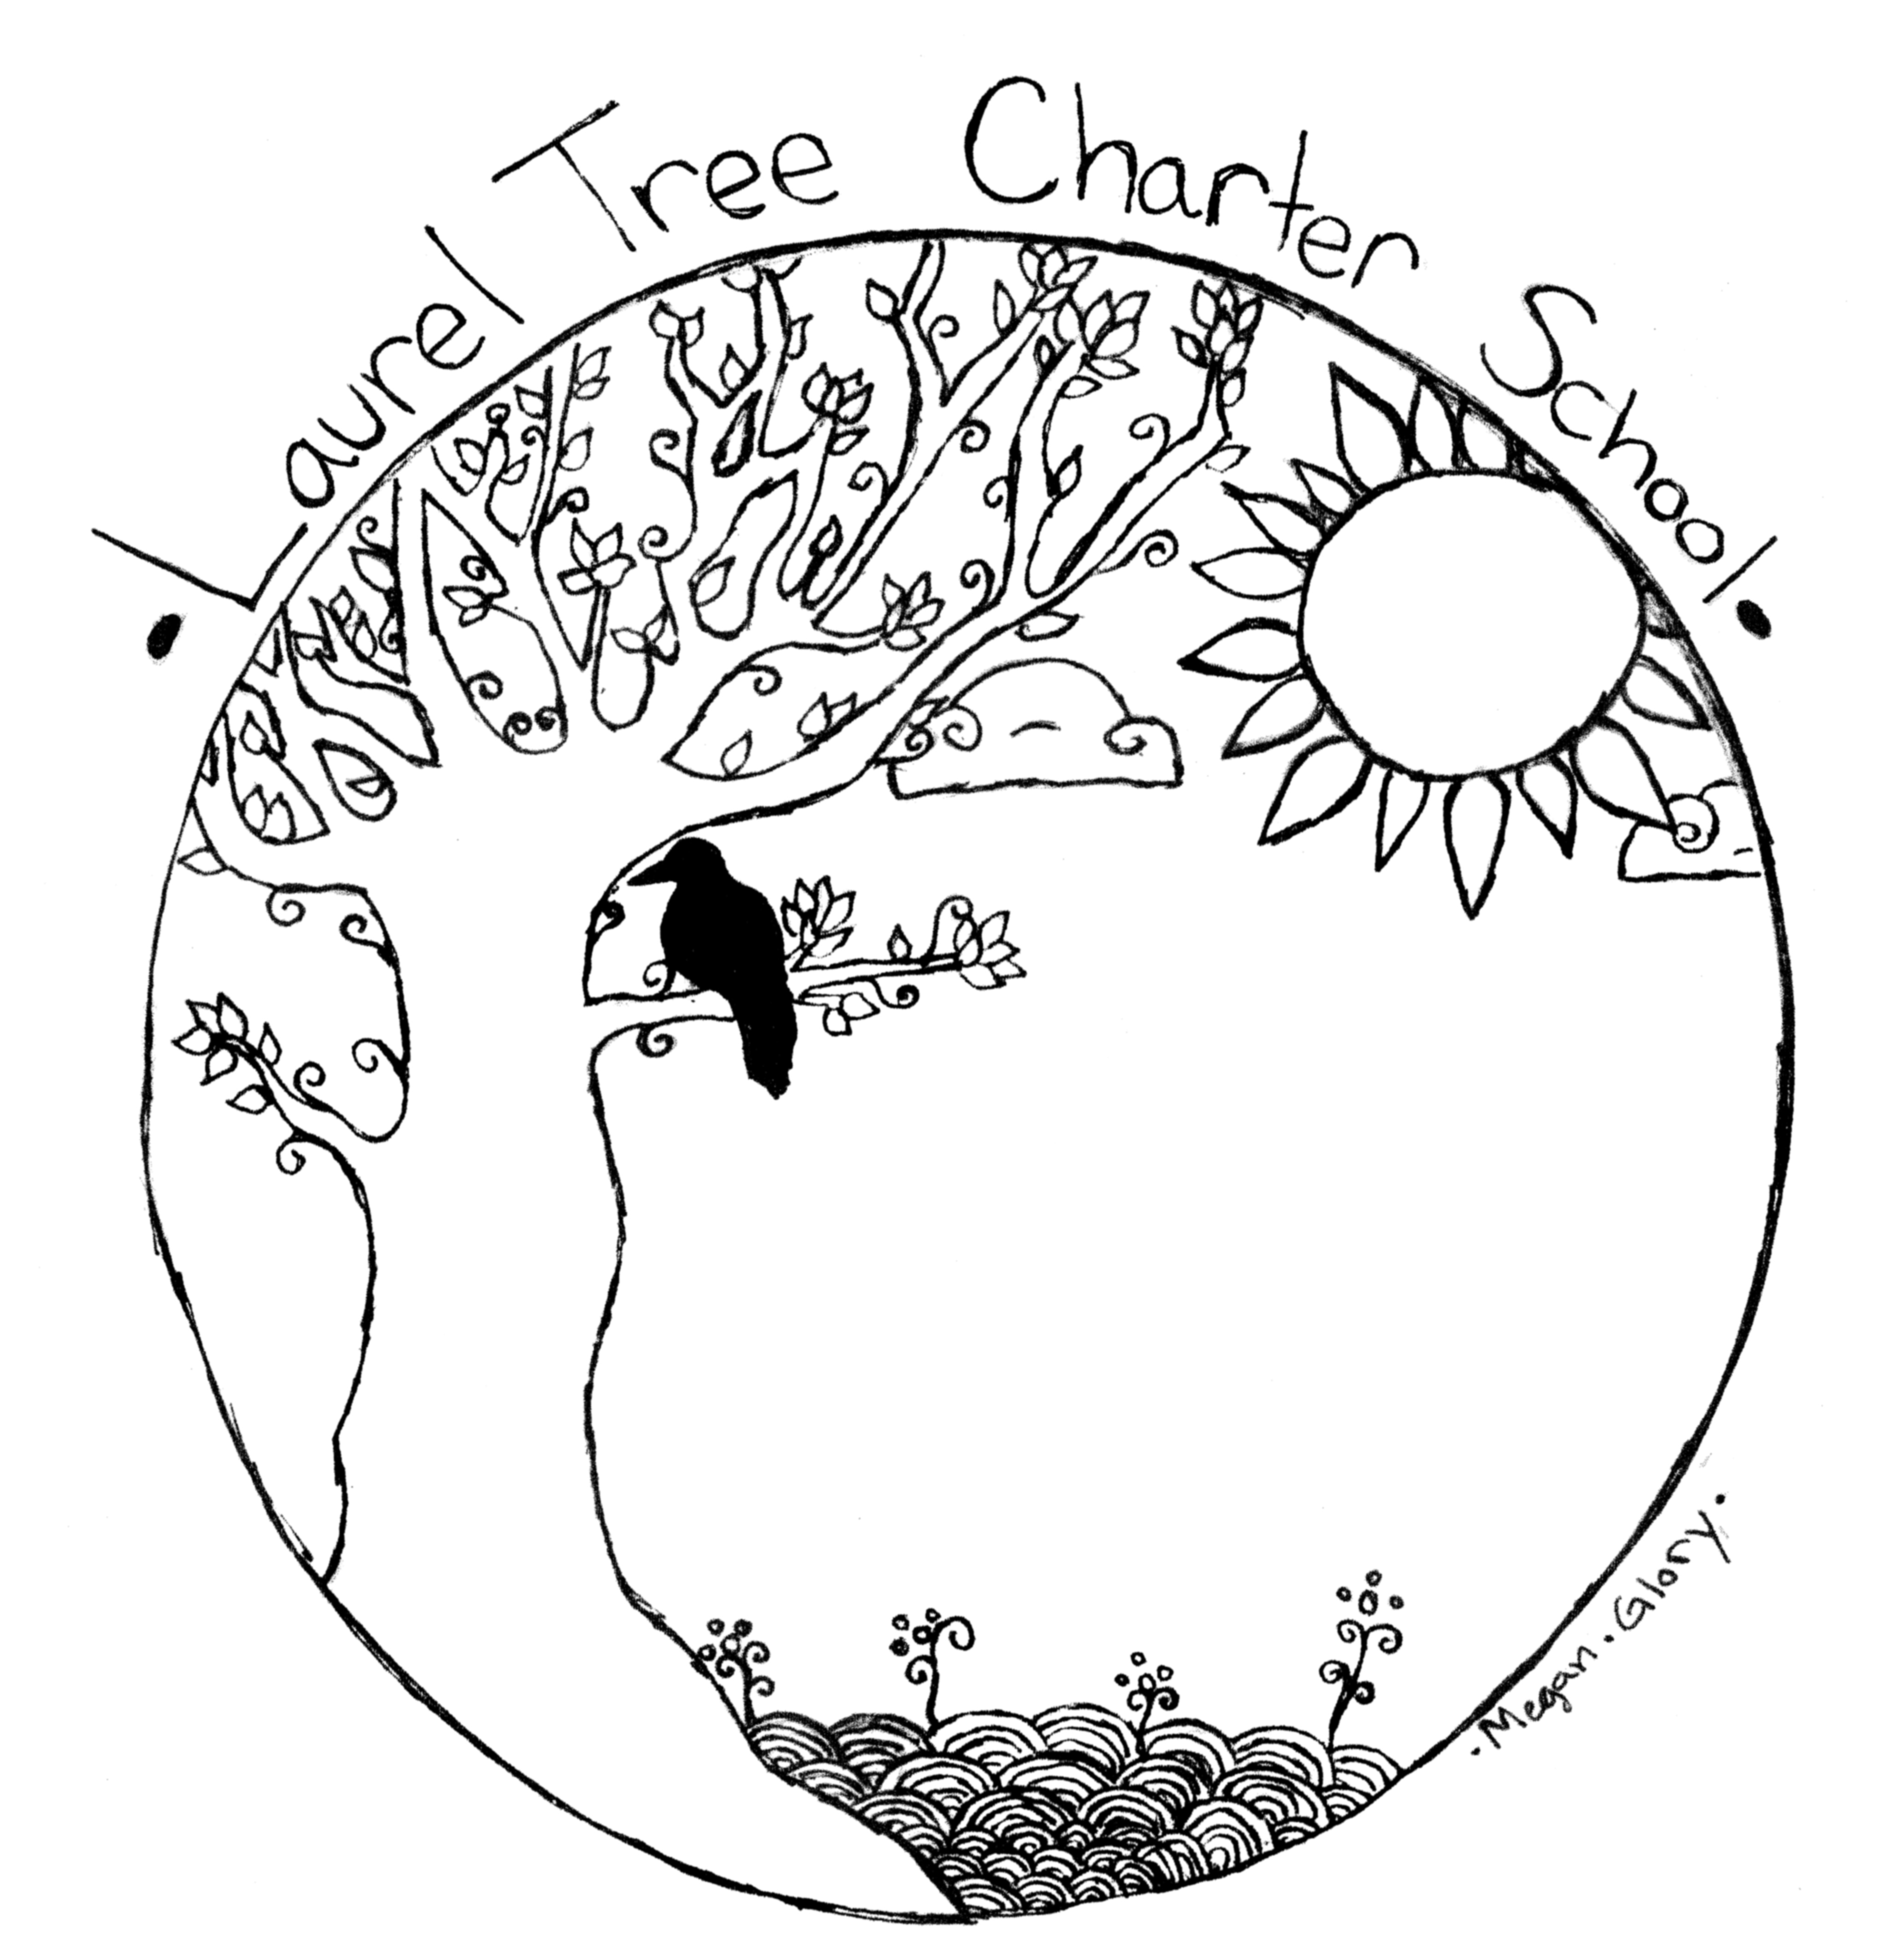 | Laurel Tree Charter School  Creating the Education We Want For Our Children  Rigor*Relevance*Relationships*Responsibility*Regeneration  4555 Valley West Blvd, Arcata, California 95521  (707) 822-5626 * www.laureltreecs.org  Laureltree_lc@yahoo.com

Laurel Tree A-Z

Aftercare/Before School Care/Extended Learning Opportunities
We provide care in the morning (and free breakfast) from 7:00 am to 8:00.
We provide drop-in supervised play and activities in aftercare for kindergarten starting at 1:00, and for our 1st-6th grade students from 3:00 to 5:30. (Payment is on a sliding scale, invoiced the following month). Daycare policies and contract are included in the back-to-school mailing.
The program running from 1pm-3pm will consist of play and social time, a nutrition break, a structured activity and student choices embedded within the routine. At 3pm, older elementary students join the program. From 3 to 5:30pm, the program will consist of TK-5th grade students and will include play and social time, a nutrition break, and opportunities for students to engage in structured activities. The program will offer a homework club for 5th grade and up (or older elementary students when appropriate) where students will have access to qualified staff that can support the completion of homework, engage students in skill building activities and games and provide a quiet space for reading and individual work.
We now offer free Extended Learning Opportunities during breaks! Winter Enrichment/Tutoring - Jan. 2-13 (two weeks) Spring Break Tutoring – 4/10-4/14 (one week) Summer Camp/Credit Recovery - July 10-28 (three weeks).

Attendance
If your student arrives after school starts, we mark them late. If your student is thirty minutes late to school, we mark them tardy. If they are not there at all that day, we mark them absent. You will get an e-mail alert via our on-line system any time they are tardy or absent if you set that in Jupiter Ed.
Three tardies = one unexcused absence (these can’t be made up).
Three unexcused absences or tardies of more than 30 minutes = contact from the school.
The Lead Teacher and School Psychologist may call a meeting with you to discuss support for helping the child attend regularly and on time. An attendance improvement plan will be signed by student, parents, and teacher(s). If attendance still does not improve, then a mandatory appearance before the School’s Governing Board is the next step. The board will offer further community support or resources but will also provide a warning that child protective services and/or the County Student Attendance Review Board may be involved as a next step.
We want to make it easy for you to make up days when your student is absent, or when you go on a family trip. Talk to your teacher about getting an independent study contract. Please fill out this independent study contract before you go on a family trip, or to make up work from an extended absence (more than three days). Turning in one of these contracts, with the work attached, allows us to collect the ADA money – and helps your child stay caught up in school. Please return it to the front office.

Birthdays/Holidays
We love to celebrate! Holidays of many traditions are shared. You are welcome to bring a treat to share for your child’s birthday. We encourage healthy foods, but special treats are fine. Some children have allergies – check with your teacher so you can have an alternative for kids that need them.

Busing
We don’t have school buses or provide transportation to and from school. We rely on parent drivers, carpooling and mass transit. We have three school vans that are used for our Forest Kindergarten Program in the morning and our Laurel Tree Wild Program in the afternoon. We rely on parents volunteers to provide us with drivers and chaperones for our many field trips. New policies require parent drivers to have driving records on file as well their auto insurance.

Calendar
The school calendar is attached at the back of the handbook. School starts on August 22. The last day of school is June 15th.

Cell Phone Policy
More and more studies are showing we all spend way too much time on our screens. We want our students to be focused on the learning we do together. High school students and adults may use them on breaks or for school related reasons. Younger students need to keep them in their bag, or turn them in to us. No cell phone use at school for primary and middle school.
Communication -Parent/Teacher Meetings
It takes a village to raise a child, and we want great communication in our village. Every Monday we send out The Leaf- Weekly Newsletter via e-mail. It has information about what’s happening around the school that week. Parents have access to their students’ grades, assignments, and to teachers’ e-mail addresses via our on-line grading system. Our website (www.laureltreecs.org) has lots of information, including our calendar. E-mail or a message through Jupiter Ed is a good way to reach us with a quick question or concern.
We have scheduled parent/teacher conferences mid-year (with early dismissal at 1pm during conference week). We also love having parents in the classroom. We ask only that you set up observation/helping time with the teacher ahead of time and that you not interrupt class time to talk to a teacher. We're very accessible before classes, after school, and via the internet - schedule a meeting so we can give you our full attention. We feel that a strong connection between teachers and parents is essential for the success of our students.

College Readiness
As a very small school, we wanted to put a special focus on making sure our graduates have access to and are ready for opportunities in college and career pathways. Our high school students take classes that have been approved by the University of California’s A-G System. They also have the opportunity to be concurrently enrolled at College of the Redwoods. We make sure that all high school students have access to computers in all their core classes, provide academic counseling and support, and create a culture of college going by taking field trips to colleges and teaching a unit on how to apply for college and FAFSA.

Counseling
Angela Malley is our full-time school psychologist. She is part of our team that works to help support students and families. She provides counseling to students, uses restorative practices to help students resolve problems, and provides testing that helps us understand how kids learn. Angela will also observe students and provide helpful feedback for teachers. She helps us write behavior plans, and provide resources and counseling connections for families.

Discipline
A calm, safe, and predictable classroom is essential to learning. When students help decide the rules and know that those rules will be fairly enforced, then behavior problems decrease and the amount of time for teaching and learning increases. With this in mind, we have students participate in setting up our classroom rules. However, students need firm, fair boundaries and grown-ups that they can count on to be in charge. Therefore, all adults in our classrooms use the following system. It is a positive way to create a respectful learning environment, as well as to help students reflect on and change behavior that is hindering their learning.
1. Proximity – Move near the student who needs support or is off task (often the same thing).
2. Praise - Praise the desired behavior in other students. “You guys are doing a great job working on that math sheet.” Praise approximate behavior changes in the student. “Good job getting started. Do you need any help?” Usually your positive presence and your offer of help are all it takes to help students get back on track.
3. Redirection – Tell the student what you want them to do, not what you want them to stop doing. “Please pick up your pencil and I’ll help you get started on this.”
4. Reflection/Replay - As a final step, students who continue to disrupt the learning environment will be sent out of the classroom. There, in a quiet, supervised space they can calm down, resolve whatever the issue is, and then return to class. Students will meet with their teacher during the next break to talk it over and decide on the consequences of their actions (mediation, restitution, making up missed work, in school suspension, or parent contact). Any out-of-control behavior (tantrums, violence, and defiance) will be excused immediately to Reflection/Replay.
We have board adopted policies that deal with more severe behavioral issues such as bullying or violence. See our full discipline policy at the back of this booklet.

Dress Code
We expect our children to come in clothes (and shoes) that allow them to run and play and move freely. We are often outdoors for learning and we expect students to dress appropriately for the weather. We respect diversity of expression among our older students so long as clothing does not contain drug references, gang references, racial slurs, or profanity.

Enrollment
We are usually full. When we have space available, we take people off our wait list on a first come, first serve basis, with a priority given to siblings of students already enrolled. Students living in the local school district (Pacific Union and Northern Humboldt Union High School) also get priority by having two tickets in the lottery. To get on the wait list, we ask that parents and their student come and observe at the school, meet with the teachers, and fill out a pre-enrollment form. We hold a lottery twice a year with the pre-enrollment forms. We add the names to our wait list in the order they were drawn from the lottery. Your student’s name remains on the wait list until we have space for you. We call everyone on the wait list in May to let them know whether they have a space for the following year.

Fieldtrips
We take a lot of fieldtrips. Forest Kindergarten is on a field trip three days a week. Our afternoon program for 1st-7th grade, Laurel Tree Wild, is often off-site. There will be a blanket permission slip for these regular parts of our academic schedule in your back-to-school packet.
The older kids (6th and up) camp together for the first week of school at Camp Mattole. This year, 8th-12th graders will have the opportunity to travel to Baja for a Marine Biology trip in February. Middle and high school will also travel to the Oregon Shakespeare Festival to see several plays in the spring. Parents are welcome and encouraged to attend as chaperones. These trips will have a separate permission slips, parent meetings, and often a fee involved.

Forest Kindergarten/Forest School Friday
Forest Kindergarten is an educational program for children that takes place outside, in all weather. It allows children to learn about their world through play and exploration. Teachers support learning with stories, songs, and activities that help develop a child’s social, physical and emotional skills as well as their academic skills. We offer a half-day Forest Kindergarten program for our transitional kindergarten and kindergarten. Our Aftercare Program is available until 5:30.
Forest School Friday is how we incorporate this into our program for older students, as well as through our afternoon projects in Laurel Tree Wild. Nine of our teachers are certified in Forest School Practices through the University of San Diego. We believe strongly that having children outside, working cooperatively on meaningful projects is an excellent way for learning to happen.

GATE
We think all of our kids are gifted and talented, and we want an enriched, rigorous, exciting curriculum for them all. Therefore, we provide challenging lessons, hands-on activities, and higher-order thinking assignments every day. We offer enrichment classes for everyone through our Laurel Tree Wild Program. We include all our students in theater productions and travel opportunities. And we support all our students to work at their highest ability level, not just their grade level.

Grades and Assessments
We use different types of assessment to help us know how our students are doing, where they need more help, and where they need more challenge. We use rubrics, portfolios, teacher observations, performance assessments, and standardized tests. These are all valuable tools that help teachers and students assess their learning and plan the next steps. We plan instruction using the Common Core Standards. We give letter grades based on these different assessments for 6th grade and up. For our primary students we use “meet, proficient, emerging and concern” to indicate their progress. Report cards are given twice a year. Rubrics assessing specific skills are given at the end of each Laurel Tree Wild session. Parents can see grades and assignments, and contact teachers through our online grading system at www.jupitered.com. See office for login information.
While we do not believe that grades accurately reflect the vast breadth and scope of students’ intelligence, we do believe they reflect how good students are at “school skills” like organization, follow through, asking for help, and working hard. These are important, and being good at these things can be a good indicator of future success.

Groupings – Multi-graded
We believe in multi-age, multi-graded, and ability grouping whenever possible. People of different ages working together promotes cooperation and community, and decreases competiveness and anxiety. Students have the opportunity to work above or below “grade level” so they can be supported or challenged as they need.
In their 11th and 12th grade year, students are encouraged to take classes through concurrent enrollment at College of the Redwoods, so they can be ready for the transition to college. High School Graduates must meet all state requirements for graduation.

LCAP
Our Local Control and Accountability Plan (LCAP) is the plan we use to improve our school. With it we set goals and measure our progress towards those goals. Parents, staff and the School Board work together to write and revise this plan yearly. We have seven goals: Goal 1- A strong connection with students, families, and community. Desired Outcomes, Goal 2- A safe school site that facilitates the kind of learning we aspire to - inclusive, sustainable, developmentally appropriate, project-based, and college and career-ready, Goal 3 - Assessment that is used to plan student supports and track individual student growth, Goal 4- Standards integrated into rich and rigorous hands-on, project-based, forest school curriculum, Goal 5- Graduates that are ready for college and careers, Goal 6- Effective teacher evaluations and professional development, Goal 7- A strong and inclusive governance team. The whole plan is posted on our website and discussed often at our Board Meetings. We’d love your input.

Lunch/Breakfast Program
We contract with local farms and vendors to provide FREE, nutritious, and delicious vegetarian lunches Monday-Friday. Amber serves up hot, homecooked meals for all – and starting this year we provide breakfast too! We have a Farm-to-Fork Grant that helps us buy locally and provide tastings/curriculum for our Edible Education Program. This year we are adding local tuna to our menu. We are part of the National School Lunch Program. Parents can help support our fabulous lunch program by making sure they have their Free and Reduced Price Lunch forms turned in each year. Having an accurate count can make a huge difference in the amount of federal money we are eligible for.

New Property
Laurel Tree is building a new school to house two hundred kindergarten through twelfth grade students. Our main building will house the office, meeting rooms, kitchen, and janitorial areas. The classrooms will be arranged in an arc to catch the sun and make maximum use of solar. We plan to open at the beginning of the 2024/25 school year. The project will be permanent construction using Green Building and sustainable practices. We have created a school design that facilitates getting students outdoors and includes permaculture, food forests, and native plant gardens, as well as wildlife areas and natural play spaces. The location of the 4.5 acre property is at 899 Murray Road and is bordered by the Hammond Trail providing walking distance access to forested areas, the Mad River Estuary, Hammond Park, and the ocean. This is the perfect location for a Forest School program. This year, the kindergarten classes will be using the new property as their base of operations!

Nurse
Our nurse comes from the County Office of Education to do hearing and vision screening, and to consult on an as needed basis.

Parent Involvement
We strongly encourage, and indeed depend upon, family involvement with our school. We believe family involvement is critical to the success of children AND to the success of our school. You are your child’s first teacher. You are an important part of our sustainable school community. We need your expertise, your enthusiasm, and your ideas.
We come together as a community four times a year at our Potluck and Performance gatherings. This is where we see the culmination of our Laurel Tree Wild projects. One group puts on a play and there are demonstrations or displays from students.
We often need parent drivers to help with field trips. Turn in a printout of your driving record from DMV (you can get it online), and a copy of your insurance in order to drive.
There is a Parent Group that is meeting monthly to help facilitate parent/school communication and provide support to the school. Parents are also encouraged to come to our monthly Board Meetings.

PE/Motor Skills
Our Laurel Tree Wild program provides a block of time in the afternoons for students in 1st-7th grade to work on motor skills, cooperation, and physical skills. Whether it’s movement games in theater class, hiking in Forest Explorers, swimming lessons and rock climbing in Community Classes, or gardening during Edible Education, we provide plenty of physical activity for growing bodies.

Individualized Education
We provide specialized academic support based on individualized education plans. Our resource team works with students in the classroom setting as well as providing small group instruction outside the classroom. Students have access to occupational therapy and other IEP driven services as needed. Our speech therapist is on campus two days a week and provides individual and small group speech therapy, as well as providing support and advice for our teachers.

Safety Plan
The school has a Safety Plan that is updated and reviewed yearly (Staff meeting and August School Board meeting). It includes everything from emergency plans and lockdown procedures to field trip protocols and discipline policies. It’s posted on our website.

School Schedule
Grade Level | Schedule | Location
TK-Kindergarten | 8:30 to 1:00 Monday-Friday  *transportation to Aftercare at the main site provided. | 899 Murray Road, McKinleyville
1st-5th Grade | 8:30 to 3:00 Monday-Thursday  8:30 to 1:00 Friday | 4555 Valley West, Arcata (main site)
6th-12th Grade | 8:30 to 3:30/3:45(HS) Monday-Thurs.  8:30 to 1:00 Friday | 1222 Hallen Drive, Arcata  (two blocks from the main site)

Sports
In the past we have had a track team and a basketball team. Many of our students play in city recreation leagues, or for their districts of residence. As we rebuild these after the pandemic, we could really use some parents as coaches or supports!

Unanswered Questions?
Check our website at www.laureltreecs.org, give us a call at 822-5626, or e-mail Brenda at laureltree_lc@yahoo.com.

Laurel Tree Charter School Discipline Policy

At LTCS, we expect and require our students to attend regularly, to demonstrate good work and study habits, and to show mutual respect to each other and teachers. We will not tolerate substance abuse, violence, or behavior that creates an unsafe emotional or physical environment.
In order to enforce these expectations, we use a progression of natural and logical consequences that are designed to help kids learn from the choices they make. Our focus is on solving problems and helping kids make better choices instead of punishment.

- All teachers use the school-wide policy of Proximity, Praise, Redirect, and Reflect in their classrooms. Teachers move near a student who is off task, needs help or is disrupting learning, they praise the desired behavior that they see other students exhibiting, they redirect the behavior - and if the disruption continues they ask the student to step out of the classroom to calm down and resolve the issue privately.

- We give students a chance to reflect on and replay the situation. We may also have students deal with the problem by making up missed work, mediating the problem if it involves another student, fixing or pay for anything damaged, and participating in a restorative circle.

- Any serious behavior issues at school are followed up by a parent contact. We contact parents via email, phone calls, face-to-face contact, and/or sending behavior reflection sheets home.

- Mediation or consequences? We use peer mediation to help students resolve conflicts when both parties are willing to do so, and when it’s appropriate. Often the mediation resolves the issue between the students, but then the consequence for the behavior is dealt with separately. For example, if a second grader hits another second grader, we would use mediation to help the two kids work out the problem. There would also be a consequence for hitting someone. The two are separate issues. We try to use natural and logical consequences whenever possible: Possible consequences for misbehavior: 1) Loss of recess 2) Restitution: fix the problem, pay for the object, etc 3) Community service: give something back to community that was disrupted 4) Confiscation: the distracting object is taken away for the day, week, or for good 5) Reflective writing: essay, behavior sheets, letters home 6) Loss of privileges: field trips, off-campus privileges 7) Phone call home 8) Sent home for the day.

- In cases where the student’s behavior brings harm to or affects the community in a negative way, we may use Circle Justice as a way to hold the student accountable to the community and have the community help resolve the problem. This is a form of restorative justice.

- For repeated issues or patterns of behavior (including lack of attendance), we may require parent-teacher conferences. If the behavior does not change after a series of conferences and interventions, we may recommend that they leave the school. If a student’s behavior is threatening to the safety of him/herself or others in the school, we may suspend students for up to ten days. Suspension may be in-school or off-campus. For serious or repeated offenses, the Administrative Team can recommend expulsion to the Board.

- More serious stuff. There are certain things defined in Ed Code that are more serious. Physical violence, a pattern of bullying, weapons, drugs, sexual harassment, etc. In these cases we follow Ed. Code and state law. Law enforcement may be called. Students may be suspended for up to ten days, pending expulsion proceedings by the School Board.

Laurel Tree Charter School Attendance Policy

We have two major concerns regarding attendance:

- Academic success is directly tied to attendance.
- School funding is directly tied to attendance

However, we feel strongly that sick kids should stay home, and that families should have the opportunity to travel together. We also want to keep the bureaucracy and paperwork to a minimum, and we're not interested in passing judgment on whether or not the absence was for valid reasons. As their parent, you are in a better position to judge that than we are. So we (and the state) are defining excused absences as those where the student is absent due to illness, quarantine, medical appointment, family reason, travel, and religious observance. Please call and let us know why your student is out. We will put together a packet of missed work and leave it in the office. By doing the missing work your student stays caught up, and we are able to receive funding from the state. Unexcused absences are when you have not called to let us know why your child is out sick, or if they are simply out for no valid reason.

Attendance Policy:

- Three unexcused absences or tardies of more than 30 minutes = truancy notice
- Two truancy notices = The School Psychologist and the Lead Teacher will set up a Restorative Circle to discuss support for helping the child attend regularly and on time. Our goal is to help the family identify the barriers to attendance and then provide support in removing those barriers. An attendance improvement plan will be signed by student, parents, and teacher(s).

Cutting School

“Cutting school” is leaving school without permission from school personnel AND parents. Consequences can include: phone calls home, a daily participation grade of “F”, restriction of off-campus privileges, loss of responsibilities, and loss of participation in off-campus field trips.

Unexcused absences (as discussed in the Attendance Policy above) will include absences due to cutting school.

